Assignment3

Output

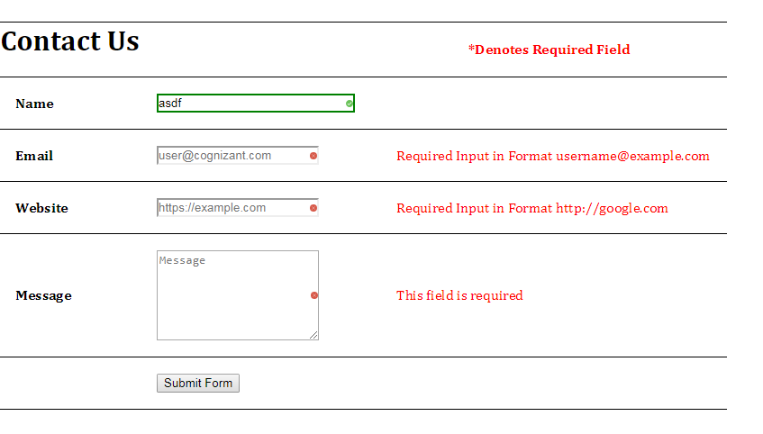

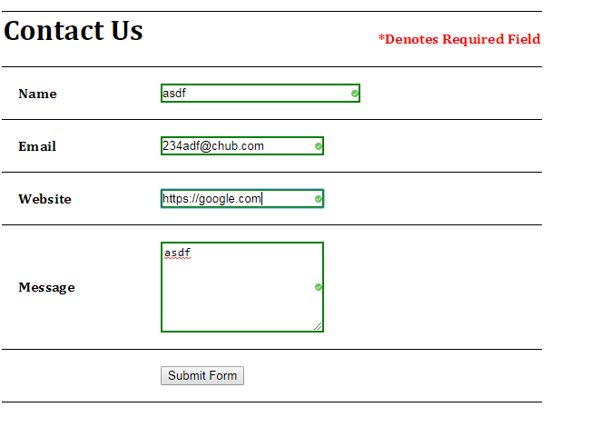

Code Snippet

<html>

<head>

<title>Html5 Assignment for CSS</title>

<script src="https://ajax.googleapis.com/ajax/libs/jquery/3.3.1/jquery.min.js"></script>

<script>

$(document).ready(function () {

// Name can't be blank

$('#Name').on('input', function () {

var input = $(this);

var is_name = input.val();

if (is_name) { input.removeClass("error").addClass("valid"); }

else { input.removeClass("valid").addClass("error"); }

});

// Email must be an email

$('#Email').on('input', function () {

var input = $(this);

var re = /^[a-zA-Z0-9.!#$%&'*+/=?^_`{|}~-]+@[a-zA-Z0-9-]+(?:\.[a-zA-Z0-9-]+)*$/;

var is_email = re.test(input.val());

if (is_email) { input.removeClass("error").addClass("valid"); }

else { input.removeClass("valid").addClass("error"); }

});

// Website must be a website

$('#Website').on('input', function () {

var input = $(this);

if (input.val().substring(0, 4) == 'www.') { input.val('http://www.' + input.val().substring(4)); }

var re = /(http|ftp|https):\/\/[\w-]+(\.[\w-]+)+([\w.,@?^=%&:\/~+#-]*[\w@?^=%&\/~+#-])?/;

var is_url = re.test(input.val());

if (is_url) { input.removeClass("error").addClass("valid"); }

else { input.removeClass("valid").addClass("error"); }

});

// Message can't be blank

$('#MessageText').keyup(function (event) {

var input = $(this);

var message = $(this).val();

console.log(message);

if (message) { input.removeClass("error").addClass("valid"); }

else { input.removeClass("valid").addClass("error"); }

});

// After Form Submitted Validation

$("#SubmitForm").click(function (event) {

var form_data = $("#Form").serializeArray();

var error_free = true;

for (var input in form_data) {

var element = $('#' + form_data[input]['name']);

var name = form_data[input]['name'];

var valid = element.hasClass("valid");

var error_element = $('#span-' + name);

if (!valid) { error_element.removeClass("Validation").addClass("Validation_failed"); error_free = false; }

else { error_element.removeClass("Validation_failed").addClass("Validation"); }

}

if (!error_free) {

event.preventDefault();

}

else {

$(this).addClass("buttonvalid");

event.preventDefault();

}

});

});

</script>

<style>

form {

font-family: Cambria, Cochin, Georgia, Times, 'Times New Roman', serif;

font-size: 20px;

}

buttonvalid {

background-color: greenyellow;

}

.valid {

background-color: greenyellow;

border-color: green;

border-width: 2px;

background: url(image/checked.svg) no-repeat;

background-position: right;

background-size: 8px;

}

:invalid {

display: block;

}

.error {

background-color: red;

background: url(image/cross.svg) no-repeat;

background-position: right;

background-size: 8px;

}

.Validation {

display: none;

margin-left: 10px;

}

.Validation_failed {

color: red;

margin-left: 10px;

}

input {

width: 180px;

}

textarea {

width: 180px;

height: 100px;

background-size: 8px;

}

body {

padding: 50px;

}

table, tr, td {

border-bottom: 1px solid black;

border-top: 1px solid black;

border-collapse: collapse;

border-spacing: 10px;

}

tr, td {

padding: 25px;

}

td {

padding: 18px;

}

.form-group {

position: relative;

padding-top: 1.5rem;

}

input.invalid, textarea.invalid {

border: 2px solid red;

}

input.valid, textarea.valid {

border: 2px solid green;

}

</style>

</head>

<body>

<form action="#" id="Form" class="simple-form">

<table class="table">

<tr>

<th>

<h1>Contact Us</h1>

</th>

<th> </th>

<th class="Validation_failed">*Denotes Required Field</th>

</tr>

<tr>

<td><b>Name</b></td>

<td><input type="text" style="width : 220px;" id="Name" name="Name" placeholder="Name" class="error"></td>

<td>

<span id="span-Name" class="Validation">This field is required</span>

</td>

</tr>

<tr>

<td><b>Email</b></td>

<td><input type="email" id="Email" name="Email" placeholder="user@cognizant.com" class="error"></td>

<td>

<span id="span-Email" class="Validation">Required Input in Format username@example.com</span>

</td>

</tr>

<tr>

<td><b>Website</b></td>

<td><input type="url" id="Website" name="Website" placeholder="https://example.com" class="error"></td>

<td>

<span id="span-Website" class="Validation">Required Input in Format http://google.com</span>

</td>

</tr>

<tr>

<td><b>Message</b></td>

<td>

<textarea placeholder="Message" id="MessageText" name="MessageText" name="MessageText" class="error" multiple></textarea>

</td>

<td><span id="span-MessageText" class="Validation">This field is required</span></td>

</tr>

<tr>

<td> </td>

<td>

<button type="submit" id="SubmitForm">Submit Form</button>

</td>

<td></td>

</tr>

</table>

</form>

</body>

</html>